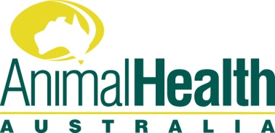
Publication and Material Order Form

Name:
Organisation:
Address:
Phone:
Email:
Quantity
APAV - Accreditation Program for Australian Veterinarians - application form and handbook
Don’t be fleeced - sheep health flyer - information buying and trading sheep
A word from the wise - goat health flyer- information on improving the health and productivity of farmed goats in Australia
National Dairy BJD Assurance Score - flyer - information on managing the risk of BJD in dairy herds
Ruminant Feed ban - brochures for livestock producers, retailers & stock feed manufacturers
MAP - information brochure on Australian Johne’s disease Market Assurance Programs
Farm Biosecurity - information brochure featuring on farm biosecurity practices to help minimise the risk to farm and industry
Screw worm fly - brochure- information on screw worm fly and the potential impact on Australian livestock
Bucks for Brains - brochure- information about eligibility for payments on submission of eligible cattle and sheep brains
Recognising Avian Influenza - DVD (for veterinarians and animal health officers)

Please subscribe to the following email publications by ticking on the left hand side:

___Animal Health Surveillance Quarterly – quarterly newsletter of Australia's National Animal Health Information System

___JD News - seasonal newsletter of the National Johne’s Disease Control Program

___Animal Health Surveillance Quarterly – quarterly newsletter of Australia's National Animal Health Information System

___AHA Update - monthly newsletter of Animal Health Australia’s activities

___Farm Biosecurity Newsletter - monthly farm biosecurity e-newsletter

___Animal Health in Australia - annual review of animal health in Australia

___NAMP Report - annual report of monitoring the distribution of economically important arboviruses of livestock and their vectors in Australia

Completed forms can be sent to Animal Health Australia at: Suite 15, 26-28 Napier Close, Deakin ACT 2600
Email: aha@animalhealthaustralia.com.au Phone: 02 6232 5522 Fax: 02 6232 5511

Privacy: Animal Health Australia will only use your details for the specific purposes of fulfilling your order as outlined above. Your details will not be passed on to any individual, organisation or entity for any other purposes.

